# Question 01

## Code

clc

clear all

close all

%Ask the user to enter horizontal position

x=get_x();

%Ask the user to enter vertical position

y=get_y();

%Ask the user to enter initial velocity

v0=get_v0();

%Ask the user to enter angle of projection

theta=get_theta();

g=9.8;

% a) and b)

% maximum height

mh=get_maxheight(v0,theta);

% Range

R=get_Range(mh,theta);

% Display maximum height and range

fprintf('Maximum height is %.2fm\n',mh);

fprintf('Range and final horizontal posistion is %.2fm\n',R);

% c)

x1=x:1:R;

y1=zeros(length(x1));

for i=1:length(x1)

y1(i)=trajectory(x1(i),v0,theta);

end

% Plot the path of motion

plot(x1,y1,'x')

%Add a grid

grid on

%Add a title to plot

title('Projectile path')

%Add labels

xlabel('x')

ylabel('y')

hold on

## Output

## 

## Graph

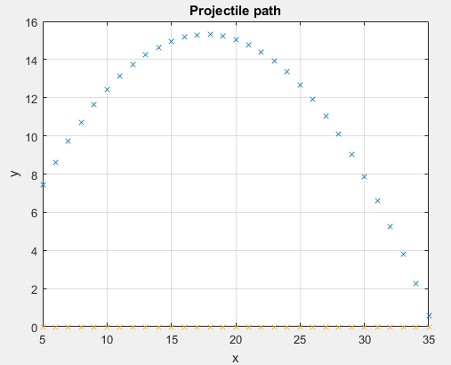

# Question 02

## Code

clc

clear all

close all

% Assume initial projectile positions

% and Initial velocity are constant

x=0;

y=4;

v0=80;

% Range for angle of projection

theta=50:10:90;

g=9.8;

disp('part a')

% a) and b)

fprintf('Theta(d)\t height(m)\t Range(m)\n');

for t = 1:length(theta)

% maximum height

ph=get_maxheight(v0,theta(t));

% Range

R=get_Range(ph,theta(t));

% Display possible height and range

fprintf('%.2f \t\t %.2f\t\t %.2f\n',theta(t),ph,R);

x1=x:1:R;

y1=zeros(length(x1));

for i=1:length(x1)

y1(i)=trajectory(x1(i),v0,theta(t));

end

% Plot the possible paths of motion

plot(x1,y1)

%Add a title to plot

title('Projectile path')

%Add a grid

grid on

%Add labels

xlabel('x')

ylabel('y')

hold on

end

disp('part c')

% c)

% Assume angle of projection

% and Initial velocity are constant

x=0;

v0=80;

theta=45;

% Range for vertical position

y=2:2:10;

% Display possible height and range

fprintf('y(m)\t height(m)\t Range(m)\n');

for t = 1:length(y)

% maximum height

ph=get_maxheight(v0,theta);

% Range

R=get_Range(ph,theta);

fprintf('%.2f \t\t %.2f\t\t %.2f\n',y(t),ph,R);

end

## Output

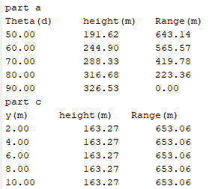

## Graph

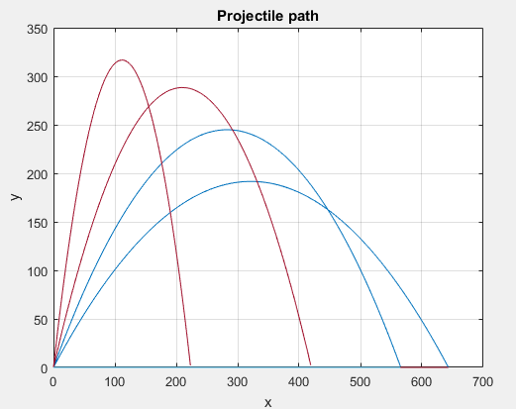

# Other function

## Trajectory

function y1=trajectory(x1,v0,theta)

g=9.8;

y1=x1*tand(theta)- ((g*x1^2)/(2*v0^2*cosd(theta)^2));

end

## Max height

%%% get_maxheight.m %%%

function mh=get_maxheight(v0,theta)

mh=(v0*v0*sind(theta)*sind(theta))/(2*9.8);

end

## Get Range

%%%% get_Range.m %%

function R=get_Range(mh,theta)

R=(mh*4)/tand(theta);

end

## get_x

%%% get_x.m %%%

function x=get_x()

x=input('Enter horizontal position(x): ');

end

## get_y

%%% get_y.m %%%%

function y=get_y()

y=input('Enter vertical position(x): ');

end